**Exercise 4.2.2 (a) Generate the 2000-ball histogram in Example 4.2.2.**

Deﬁnition 4.2.1



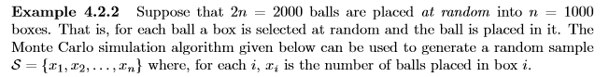

Resultado no Código.

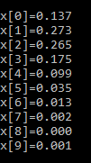

->Histograma ^f(x) versus x

**(b) Verify that the resulting relative frequencies ˆ f(x) satisfy the equation**

**^F(x) ∼ = 2^x exp^(−2) x = 0,1,2,...**

**X!**

Sim as frequências relativas do exemplo 4.2.2 satisfazem essa equação.

^f(0) = (2^0 exp^(-2))/0 =tende ao infinito 0,1353

^f(1)= 0.27067056647 ~=0,273

^f(2)= 0,2706 ~=0,265

^f(3)=0,180 ~=0,175

...

**(c) Then generate the corresponding histogram if 10000 balls are placed, at random, in 1000 boxes.**

Código.

**(d) Find an equation that seems to ﬁt the resulting relative frequencies well and illustrate the quality of the ﬁt.**